Study Guide
Matter & Properties /Physical & Chemical Changes
Fill in the blank with the correct answer.
- ____________ is a measure of how much matter is in something.
- ___________ is anything that has mass and takes up space.
- ____________ is the amount of space something takes up.
- A _____________is used to measure mass.
- _______________ are the best unit of measurement for mass.
- A ______________ is an instrument used to measure the volume of a liquid.
- How do you find the volume of an irregularly shaped object?______________________________________________________________________
- A _______________________ are characteristics of a substance that can be observed or measured without changing the substance into something else.

- A _______________________ occurs when one or more substances change into a new substance.
- A burning log is an example of what type of change occurring?_______________________
- Melting ice is an example of what type of change occurring? ________________________
- Cutting a piece of paper is an example of what type of change occurring? _________________
- A piece of iron that has rusted is an example of what type of change occurring? _________________
- Slicing a loaf of bread is an example of what type of change occurring? ________________
- The steam that occurs from water boiling is an example of what type of change occurring? ____________________
- ______________________ is the process by which a liquid changes into gas.
- ______________________is the process by which a gas changes back into a liquid.
- The three states that most matter occur in are _________, ___________, and ____________.
- Changes in state are caused by changes in __________________.
- The particles in a _____________ are close together and do not move much.
- The particles in a _____________ are spread far apart and move fast.
- A ________________ is a state of matter that has a definite shape and a definite volume.
- A _________________ is a state of matter that has a definite volume but not a definite shape.
- A _________________ is a state of matter that does not have a definite shape or volume.
- The _______________ of substances is its ability to be dissolved.

Write soluble or not soluble for each of the following substances.

- Salt ______________ 29. Pepper ________________
- Sugar ____________ 30. Sand _________________
- Cooking Oil ________________ 31. Baking Soda _____________
Write the name for the following measurement instruments and write which physical property would be measured by the instrument.
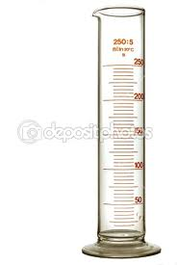
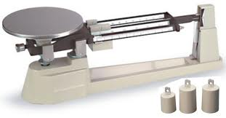
32. 33.

_______________________ __________________________
________________________ __________________________
Fill in the blanks with the correct measurement.
34. What is the measure of the liquid in the instrument below? _______________mL

